**Laboratory work 11**

**JQUERY**

jQuery is an open-source JavaScript library. It is lightweight and helps when we have to write less and do more.

jQuery is used to take a bunch of common tasks that require many lines of JavaScript code and wraps them into various methods. This method can be called with a single line of code. Thus making it easy to use JavaScript on your website.

It helps web developers to add extra functionalities to their websites. It is the most popular JavaScript library used to traverse and manipulate the HTML DOM tree. Also, it simplifies event handling, CSS animation, and Ajax.

TASKS:

1. (10%) [**https://www.freecodecamp.org/learn/front-end-development-libraries/#jquery**](https://www.freecodecamp.org/learn/front-end-development-libraries/#jquery)

*Sign In with your account.*

READ THEORY, then do PRACTICE. **Should be done first** before next tasks. **At the end send the screenshot showing that the task was done by you.**

1. (20%)[**https://www.khanacademy.org/computing/computer-programming/html-js-jquery**](https://www.khanacademy.org/computing/computer-programming/html-js-jquery)

*Sign In with your account*. At the end send the screenshot.

WATCH VIDEOS, read review, then do Challenges. All lessons should be finished. **At the end send the screenshot showing that the task was done by you.**

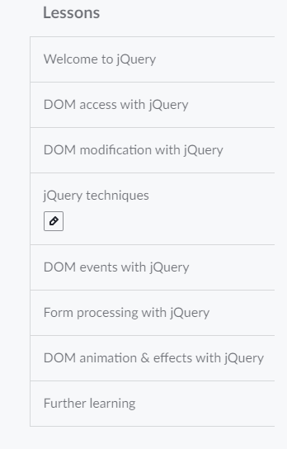

* *You can see from here how to add jQuery to your Web pages* <https://www.w3schools.com/jquERy/jquery_get_started.asp>
* What is $( document ).ready()?

<https://learn.jquery.com/using-jquery-core/document-ready/>

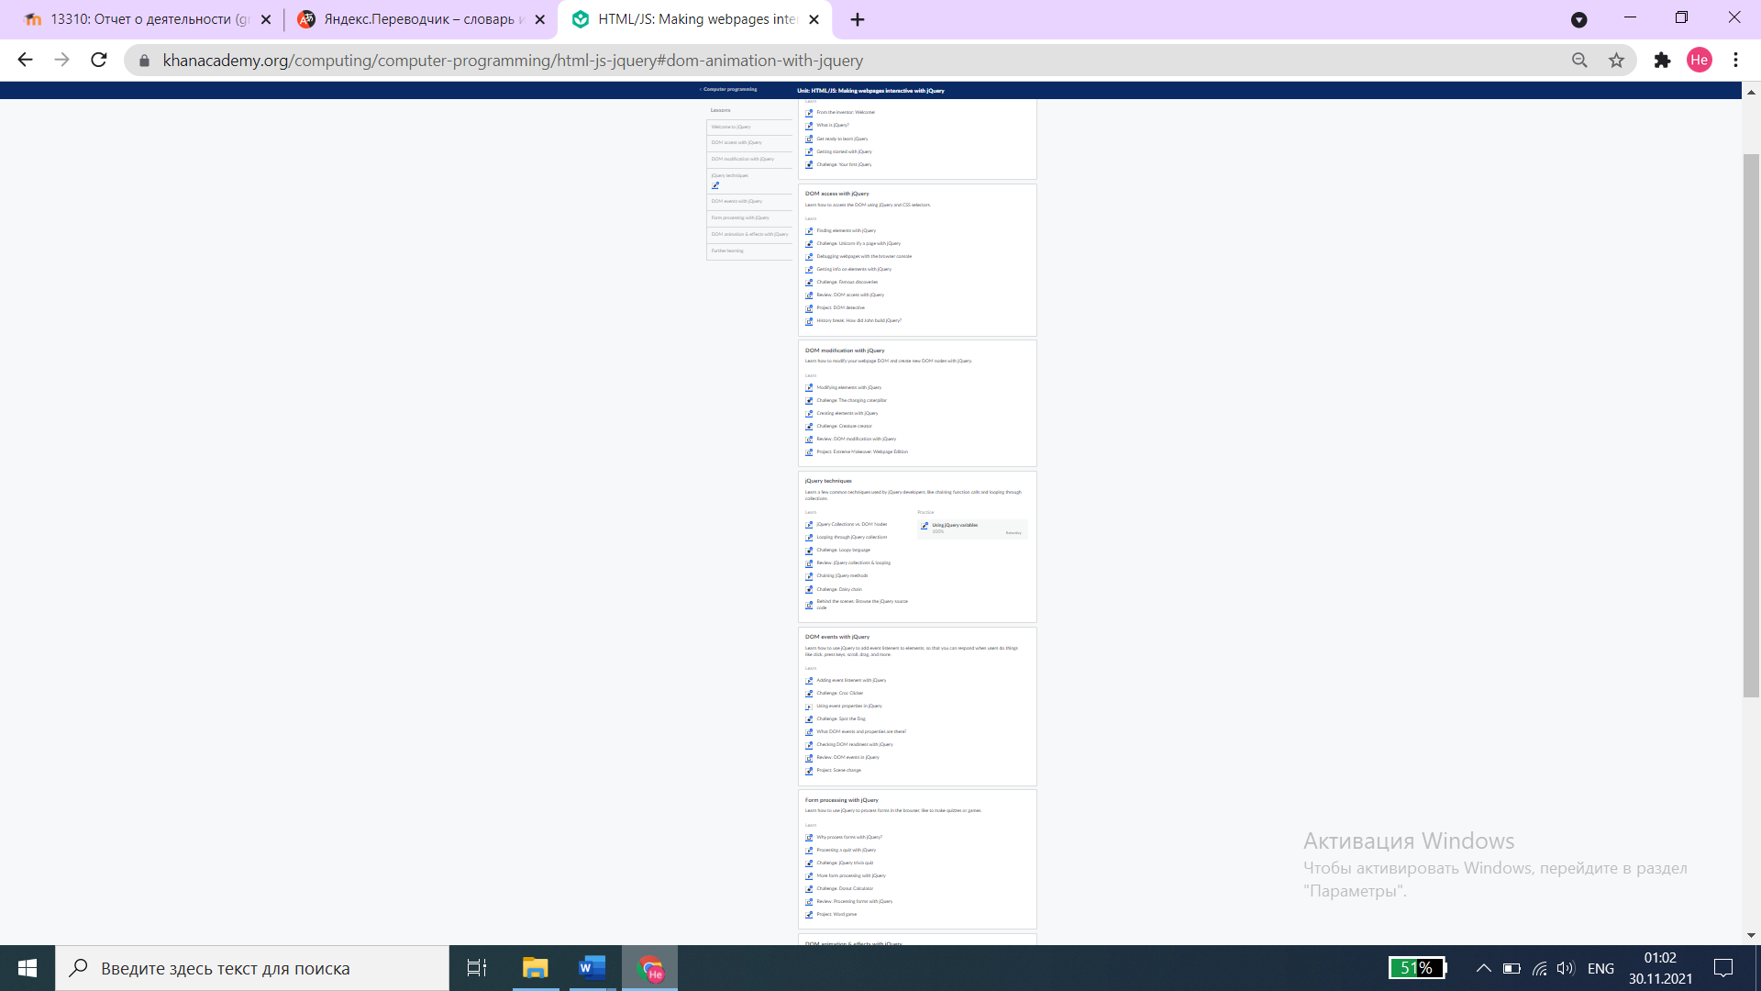

1. **RESPONSIVE FORM VALIDATION**

**A design in Figma** will be send to a group leader. Use that Design to create this form validation.

* Login/Sign In page should be connected to Register/Sign Up page. If user has an account, the user should be able to go to Sign In page. If user doesn’t have an account, the user should be able to go to Sign Up page.
* Also, DO MOBILE version (15%)
  1. (25%) Do **Form Validation** using HTML, CSS and only **JS**
  2. (30%) Do **Form Validation** using HTML, CSS and only **jQuery**

**When you are graded, a bit more focus will be given to jQuery and JS logic.**

* **Deploy these 2 parts of 3rd task to your Github**
* **Send the LINK to your Github page to DL.**

**IF YOU SEND FILE instead of GITHUB, you task won’t be graded.**

**!!!Read**

**Form validation** normally used to occur at the server, after the client had entered all the necessary data and then pressed the Submit button. If the data entered by a client was incorrect or was simply missing, the server would have to send all the data back to the client and request that the form be resubmitted with correct information. This was really a lengthy process which used to put a lot of burden on the server.

JavaScript provides a way to validate form's data on the client's computer before sending it to the web server. Form validation generally performs two functions.

* **Basic Validation** − First of all, the form must be checked to make sure all the mandatory fields are filled in. It would require just a loop through each field in the form and check for data.
* **Data Format Validation** − Secondly, the data that is entered must be checked for correct form and value. Your code must include appropriate logic to test correctness of data.